Camera Sensor

Qualification Report

Document Title: | Qualification Report
Project Identifier:
Project Target Release:
Project Short Description:
Document Owner: | Heba Safwat
Document Responsibility: | Brightskies
Document Version: | 0.1
Document Classification: | Confidential
Document Status (Draft | Final):
Document Archive:

Table of Contents
1. Introduction 4
2. Camera Sensor Component Overview 4
3. Camera Sensor Qualification Responsibility 4
4. Qualification Approach and Criteria 5
4.1 Compliance with ISO26262 5
4.2 Qualification Criteria 5
4.3 Qualification Environment 5
4.4 Qualification Activities & Deliverables 5
4.4.1 Component Identification 5
4.4.2 Static Analysis 5
4.4.3 Safety Analysis “FMEA” 6
4.4.4 Component Testing & Verification 7
5. Qualification Evaluation 7
6. Conclusion and Summary 7
List of Tables
Table 1: Revision History 3
Table 2: Version Review 3
Table 3: List of abbreviations 3
List of Figures
Figure 1: Design principles for software unit design and implementation 6

Copyright
Reproduction or utilization of any part of this document by any means, including photocopying and microfilm, without permission in writing by Brightskies is strictly forbidden.

Document Revision History
Revision  No. | Revision Date | Author | Description
0.1 | 09/06/2026 | Heba Safwat | Initial Version
Table 1: Revision History
Version Review
Version Reviewed | Reviewer Role | Reviewer Name | Approval Date | Note
Table 2: Version Review
Abbreviations
Explanation of used abbreviations
Abbreviation | Explanation
ASIL | Automotive Safety Integrity Level
FMEA | Failure Mode and Effects Analysis
Soc | System On Chip
SW | Software
SerDes | Serializer - Deserializer
I2C | Inter Integrated Circuit
VIN | Video Input
Table 3: List of abbreviations

- Introduction
This report has been prepared to provide an evidence for the qualification of the Camera Sensor component to ASILB component suitable for re-use in items developed in compliance with ISO26262:2018. It identifies and describes all the qualification activities and deliverables carried out during the safety lifecycle of the software component under qualification.
This report will mainly describe the following:
- The Camera Sensor component identification.
- The Camera Sensor component qualification strategy.
- The organization responsible of the qualification process.
- The qualification process outcomes and the evaluation of these outcomes
- Camera Sensor Component Overview
The Image Sensor Component is responsible for controlling and configuring the external camera sensor module and enabling image data acquisition within the system. It manages sensor initialization, mode configuration, communication over the I2C interface through the SerDes link, and coordination with the video input (VIN) interface to ensure correct image streaming.
- Camera Sensor Qualification Responsibility
Brightskies is responsible for the qualification of Camera Sensor SW component to ASILB component in compliance with ISO 26262-8:2018 clause 12.
Brightskies has managed and performed all activities and deliverables required for the Camera Sensor component qualification.

- Qualification Approach and Criteria

Compliance with ISO26262
The qualification activities and deliverables of Camera Sensor to ASILB component were planned and executed in compliance with ISO 26262:2018. The SW component qualification process stated clearly at ISO 26262-8:2018 clause 12.

Qualification Criteria
The qualification criteria of Camera Sensor to ASILB SW component mainly include:
- The component identification
- Evidences of the component compliance with its requirements
- Evidences of the component suitability for its intended use

Qualification Environment
The environments used for the component qualification provide a controlled setting where the software component can be thoroughly evaluated, tested, and verified to ensure its functionality, reliability, and compliance with ISO26262:2018.
The following environments were used during the qualification process:
- Visual Studio Code was used for code development and regression testing.
- poly space was used for the static analysis activities.
- VectorCast embedded software testing environment was used through the testing processes.
The confidence level for all the used tools and environments were assessed and verified as mentioned in the (01. TCL_Report_MEKRA_Rev0.1.xlsx)

Qualification Activities & Deliverables

Component Identification
The Camera Sensor component is clearly identified in the component design document with all the functions description, requirements, prototype, interface parameters, and interface returns.

Static Analysis
Static analysis performed to examine the source code without executing it, with the goal of identifying potential defects, vulnerabilities, coding errors, and adherence to coding standards. poly space software was used for the static analysis activities.
The static analysis report shows the resolution of violations mentioned in the report along with justifications for the unresolved violations in the released version of code.

Safety Analysis “FMEA”
Software Failure Mode and Effects Analysis (FMEA) was performed to systematically analyze potential failure modes and their effects on the functional safety of the component.
In addition, the SW FMEA includes the assessment of the code's quality, correctness, adherence to coding standards, and identification of any defects or issues found during the review process was executed.
Inspection was made following ISO26262-6:2018 design principles for software unit design and implementation.
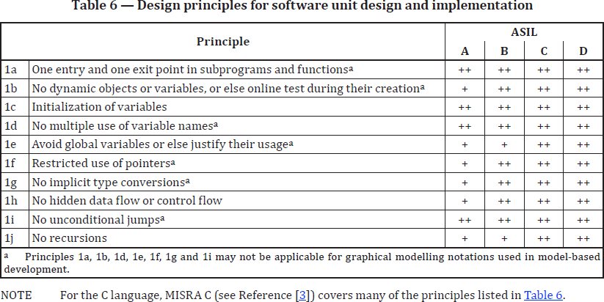
Figure 1: Design principles for software unit design and implementation
(03. fmea_SOW_2.xlsx) shows the SW safety requirements defined to address the safety mechanisms derived from the SW FMEA to mitigate the identified failure modes and reduce their impact on safety. Safety mechanisms implementation confirmation is reported in the (05. Safety_Mechanisms_Report_CameraSensor_Rev_0.1.xlsx).

Component Testing & Verification

Test plan
Test plan derived to describe the component unit testing areas and activities. It outlined the test strategy, objectives, test schedule, required resources, test estimation and test deliverables.

Test Execution and Reporting
Methods of deriving test cases and structural coverage metrics were according to the required ASIL level of the component “ASIL-B” in compliance with ISO 26262-8:2018 clause 12.
Test report derived to document the testing activities performed on the Camera Sensor component. It documents the derived test cases, and results obtained from the test execution. The traceability relationship between requirements and test cases were state in the test report. Traceability ensures that each requirement is properly implemented, tested, and validated.

- Qualification Evaluation
Confirmation Measures:
The safety confirmation measures are defined on the highest classification of the safety requirements of a safety function “ASIL-B”.
According to ISO 26262-2:2018, confirmation reviews have been executed for safety plan, safety analyses, and safety case. The review comments have been resolved and justifications have been added to the below confirmation review reports:
- Safety Plan Confirmation Review Report
- FMEA Confirmation Review Report
- Safety Case Confirmation Review Report
- Conclusion and Summary
The activities and deliverables mentioned in this qualification report serve as proof that the Camera Sensor component has been successfully qualified to ASIL-B component in compliance with ISO 26262-8:2018 clause 12.

